Büchen, June 2024

NORMTEILWERK ROBERT BLOHM has a wide selection of locating pins and rest pads

Secure, align, stabilise

They are first-class fasteners, securing specialists or have a supporting function: The Rest pads and locating pins from the comprehensive BLOHM range offer users innovative quality solutions for fastening, aligning and stabilising components.

Be it to fasten machine elements, stabilise motors or securely mount electronic components – The standardised locating pins and rest pads from BLOHM meet the highest standards of quality and precision. This is primarily due to the fact that all the necessary manufacturing processes, such as turning and grinding these hardened precision parts, are performed at the production site in Büchen. This in turn results in a high level of manufacturing expertise and short lead times for high-quality components.

It goes without saying that there is also a special focus on using high-quality materials. "The choice of material is crucial for the functionality and durability of the locating pins and rest pads in the various applications," says Mathias Marbs, sales representative at BLOHM. "Accordingly, our range includes pins and pads made from stainless steel, Q&T steel and tool steel."

Locating pins ensure a stable connection
Locating pins enable a secure, stable and precise connection between two components and make a significant contribution to the functionality and integrity of machines, devices and structures. Most of the cylindrical components have a shaft. Some may have an internal thread in the head, so that they can be connected to other components and ensure that the pin is placed in the desired position A locating face or wide support face be used to locate or support. BLOHM provides the customer with a large number of product types that can be perfectly adapted to the respective application.

One example from the BLOHM locating pin range are Ball-end locating pins – a design that significantly simplifies the assembly process. "The ball-end minimises the jamming effect - as often experienced with drawers - if a part being mounted is at an angle or the forces acting on it are not along the axis of the pin," explains Mathias Marbs. " BLOHM offers different models with different forms of this type, to suit various requirements and fits."

Rest pads - Supporting tools and workpieces
While locating pins are used to connect and position components to each other, rest pads are normally used as supports and risers. These pins are mostly cylindrical, have a shaft or screw one end and a flat support face the other end. The BLOHM range includes a wide selection of rest pads. Depending on the type, some rest pads are also referred to as support bolts or jack screws and can be customised as required to suit specific applications.

BLOHM also has different types of positioning and fixture feet on offer. These are used as supports, stops and thrust pads for fixtures and general machine and appliance construction.

(Characters including spaces: 3,251)

Short profile of NORMTEILWERK ROBERT BLOHM

NORMTEILWERK ROBERT BLOHM, founded in Schleswig-Holstein in 1934, is a renowned manufacturer of drill bushes and sophisticated customised solutions. The company also offers its customers a comprehensive range of standard and operating parts. As a specialist in the production of rotationally symmetrical parts, BLOHM has stood internationally for the highest precision and quality for 90 years.
Our portfolio includes around 35,000 high-quality products that, due to their stability, can withstand high loads and also meet special requirements. This means we primarily target partners from trade and industry who rely on durable and high-quality parts. We have our own high-performance and modern machine park at our disposal for the production of precision parts. Possible areas of application for the various bushes and standard parts are machine, special machine and plant construction as well as mould and tool making. We value long-term partnerships with our customers, highest quality and punctual delivery. With an eye on the future, we have also been training the next generation of skilled workers for decades.
Image overview:
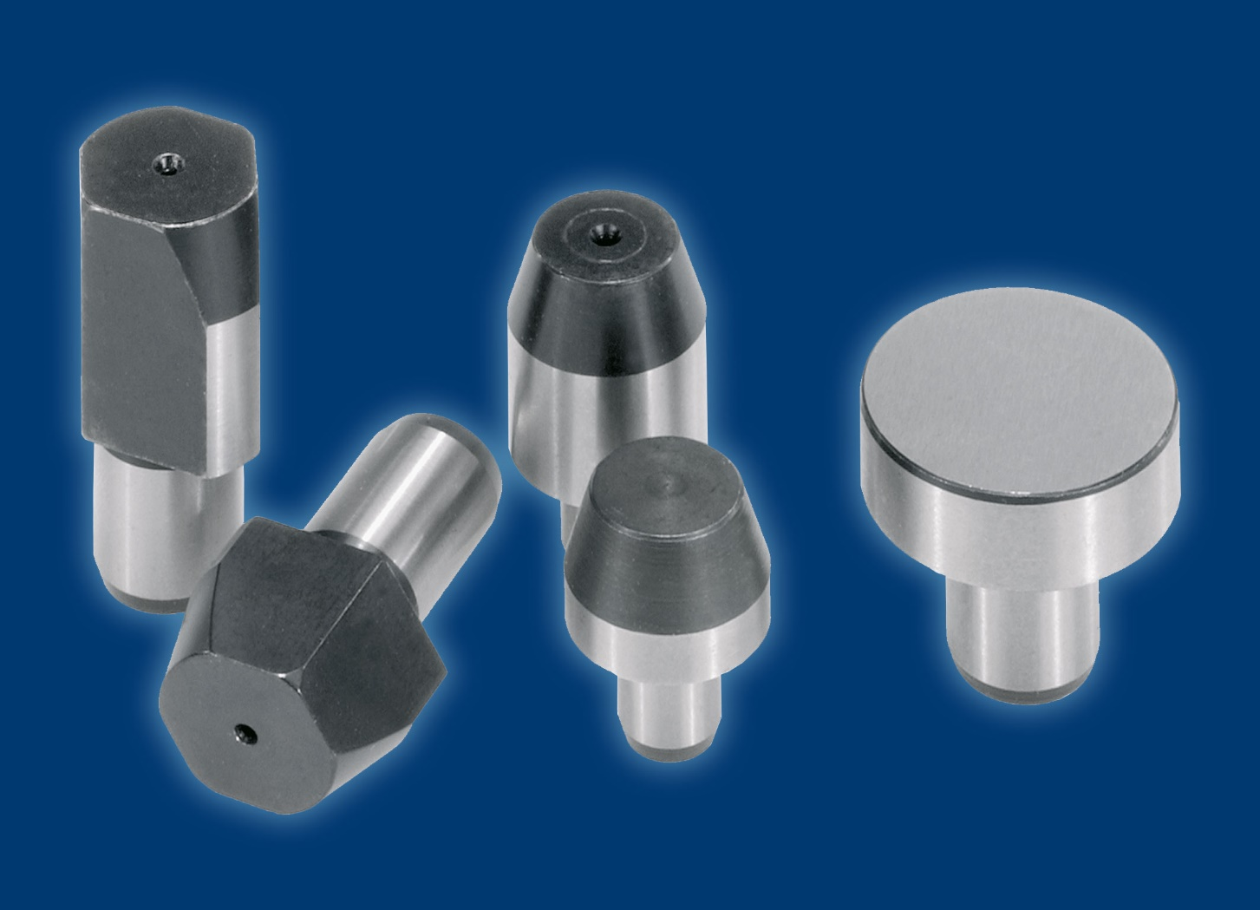
Blohm_Aufname-Auflagebolzen.jpg
DIN 632 locating pins and rest pads: The reliable aids from NORMTEILWERK ROBERT BLOHM offer the user innovative quality solutions for fastening, aligning and stabilising components. Image: NORMTEILWERK ROBERT BLOHM GmbH

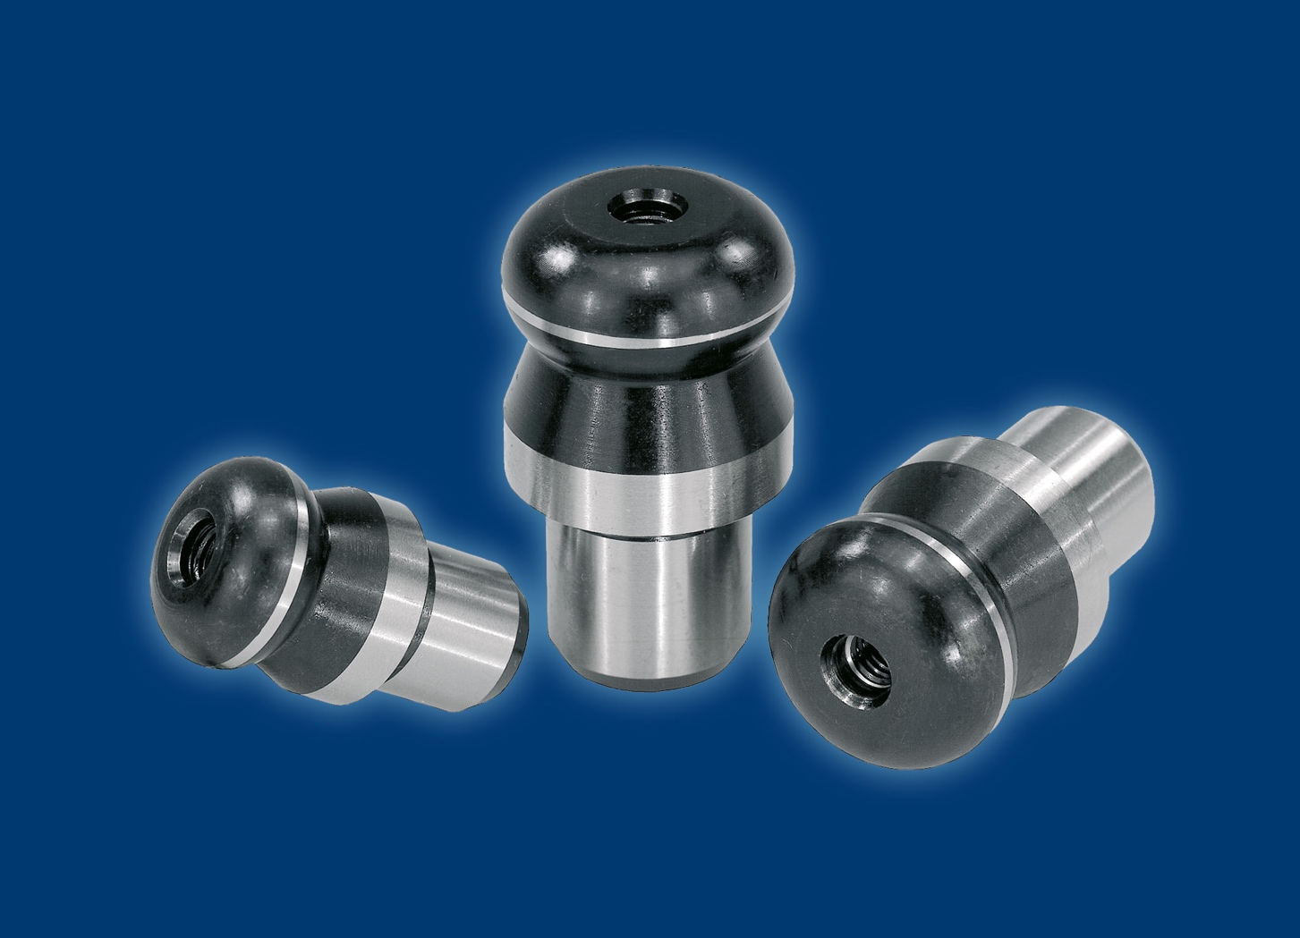
Blohm_Aufnahmebolzen mit Kugelansatz.jpg
Locating pins with ball-end (Form B) facilitate the fitting process, as they are designed for this purpose. The tendency to jam, as experienced with drawers, is minimised by the ball end and the following bevel. Image: NORMTEILWERK ROBERT BLOHM GmbH

Meta title: BLOHM | Locating pins and rest pads

Meta description: The standardised locating pins and rest pads from NORMTEILWERK ROBERT BLOHM fulfil the highest demands on quality and precision.

Keywords: NORMTEILWERK ROBERT BLOHM, BLOHM, locating pin, rest pad, locating pin with ball-end, standard parts, DIN 6321,

Deeplinks:
https://www.blohm-gmbh.de/de/en/Home.html

https://www.blohm-gmbh.de/de/en/Products/Product-overview/Locating-elements-stop-elements-support-elements/Locating-pins-rest-pads.html

https://www.blohm-gmbh.de/de/en/Products/Product-overview/Locating-elements-stop-elements-support-elements/Locating-pins-rest-pads/Locating-pins-with-ball-end-Form-B.html

Download area:
https://www.blohm-gmbh.de/de/en/Download/Press-area.html

NORMTEILWERK ROBERT BLOHM GmbH
Adriana Klink
Bahnhofstraße 20
21514 Büchen, Germany
Telephone: +49 7454 793-7648
Fax: +49 7454 793-133
Email: adriana.klink@blohm-gmbh.de

Press office:
Köhler + Partner GmbH
Brauerstrasse 42 • 21244 Buchholz i.d.N.
Telephone +49 4181 92892-0 • Fax +49 4181 92892-55
info@koehler-partner.de • www.koehler-partner.de

