Customised production and precision grinding at NORMTEILWERK ROBERT BLOHM
If it Needs to be Perfect

NORMTEILWERK ROBERT BLOHM means high-level expertise in the production of precision parts. This specialisation clearly sets the mid-sized enterprise based in Büchen in the north of Germany apart from standard parts production and ensures its position as a reliable partner for individual customer solutions. Primary focus lies on precision production of complex components in compliance with the highest quality standards.

Customised manufacture, with a rapidly growing share of total sales in recent years, plays a key part in BLOHM’s product and service portfolio. Unique selling points are the high level of vertical integration and customer proximity related with the production site in Schleswig-Holstein. "Our strength is found in the full production chain that we can map in-house – from turning and hardening to precision grinding and final measurement," explains Mathias Marbs, sales representative at BLOHM. This comprehensive approach allows the company to efficiently and precisely produce not only mass production parts such as bushings and bolts, but also highly complex customised components for customers from various industries.

The advantage for customers is obvious: they benefit from an integrated production process that covers all relevant steps. This allows production time to be reduced, precision of the end products to be continuously checked, documented and, if necessary, improved. "Our technologically advanced machinery, along with the expertise of our employees, are the basis of customised production at BLOHM," emphasises Mathias Marbs. "In doing so, we are creating the conditions for vertical integration that is unrivalled in the industry."

Precision Grinding: Expertise Right Down to the Last µm
Precision grinding take centre stage at BLOHM. This technology is crucial to achieving the high levels of accuracy required by customers. "In the field of precision grinding, tolerances in the µ range is our daily business," explains Mathias Marbs. "It's the prerequisite for achieving the high levels of precision required by our customers." This high level of accuracy is particularly important in demanding industries such as machine construction, drive technology and aerospace.

Technical equipment and modern machinery ensure that even the most complex components can be processed with the highest precision. The quality of sanding processes is guaranteed by high-precision measuring technology in the QA department. Regular maintenance of production facilities and defined inspection batches guarantee that the high quality remains constant throughout the entire production process.

Expertise as a Success Factor
Besides state-of-the-art production technology, the high professional competence of our employees is another key success factor of BLOHM. "Our specialists are essential when it comes to meeting our customers' needs," emphasises Mathias Marbs. The company is therefore focussing on training and continuous qualification of its employees. "We generally train our specialists ourselves and ensure that their knowledge is always up to date through regular training programmes."

While doing so, BLOHM pursues a long-term approach. Expertise and experience of employees is seen as valuable resources that need to be continuously encouraged and developed. This knowledge, in combination with state-of-the-art technical equipment, allows BLOHM to successfully realise even highly complex customer projects.

One example of a particularly demanding customer solution is the production of high-precision worm shafts. To do this, a blank is first turned, whereby high-precision centring has to be maintained. Then it is hardened and cylindrically ground before being shaped into its rotor profile using a special grinder. Particularly important is a so-called first part approval required for each production step. This entails that once the respective machine has been set up, an initial part is manufactured that has to be approved by quality control before series production can begin. This procedure ensures that component quality is maintained in series production and the reject rate is kept to a minimum.

Such projects illustrate the innovative strength and technical expertise that BLOHM introduces to customised production. "The challenge of such projects lies in the combination of high complexity and required precision," says Mathias Marbs. "But it is precisely tasks like these where we can bring to bear our strengths in full."

On equal footing with customers
One of BLOHM's strengths is its customer proximity and close co-operation in all phases of a project. As naturally the optimum solution is not created in one day. It rather takes a lot of consultation, fine and detailed work and a few sample parts to get there. "In terms of speed and flexibility, as a small mid-sized company with a high level of vertical integration and expertise, we are ideally positioned," Mathias Marbs summarises. "Close co-operation within the company and fast response times ensure that we are able to action projects quickly and implement short delivery times. Last but not least, our good intuition for the needs of our customers means we are able to meet them on equal footing in every respect."

Complexity driving growth
BLOHM is observing a clear trend in the market for precision manufacturing and customised solutions. Demand on complexity of components is increasing. "Our customers increasingly expect tailor-made solutions for ever more complex custom parts," summarises Mathias Marbs. "At BLOHM, we see these developments extremely positive, as we, as a contract manufacturer, are in high demand in this area and are ideally positioned."

(Characters including spaces 6.052)

Short profile of NORMTEILWERK ROBERT BLOHM
NORMTEILWERK ROBERT BLOHM was founded in 1934 and is a renowned manufacturer of drill bushes, standard and operating parts as well as sophisticated custom solutions according to customer drawings. For 90 years, BLOHM has specialised in the production of rotationally symmetrical parts and has stood for the highest precision and quality internationally.
Our portfolio includes around 38,000 high-quality products that, due to their stability, can withstand high loads and also meet special requirements. We are therefore primarily targeting partners from trade and industry who rely on durable, high-quality parts. We have high-performance, state-of-the-art machinery for the production of precision parts at our disposal. Possible areas of application for the various bushes and standard parts are machine, special machine and plant construction as well as mould and tool making. We value long-term partnerships with our customers, highest quality and timely delivery. With foresight, we have also been training the next generation of skilled workers for decades.

Image overview:
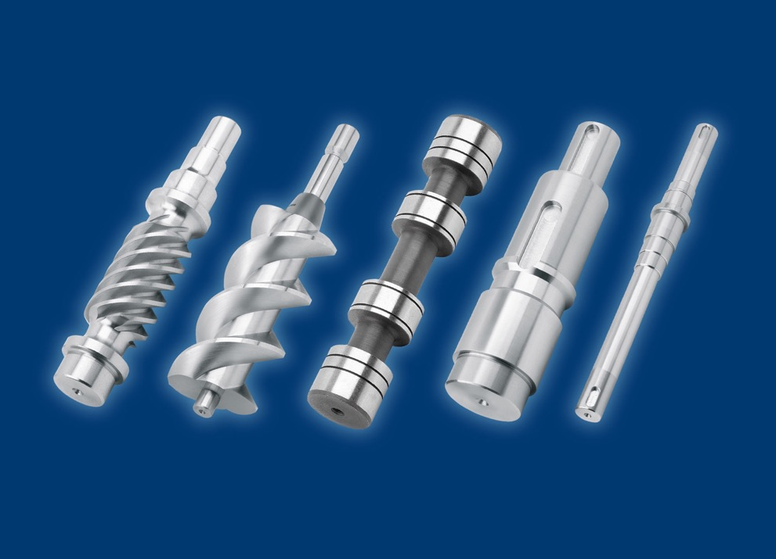
01_Blohm_Sonderfertigung.jpg
BLOHM stands for high-level expertise in precision production of complex customised special solutions in compliance with the highest quality standards.
Image: NORMTEILWERK ROBERT BLOHM GmbH

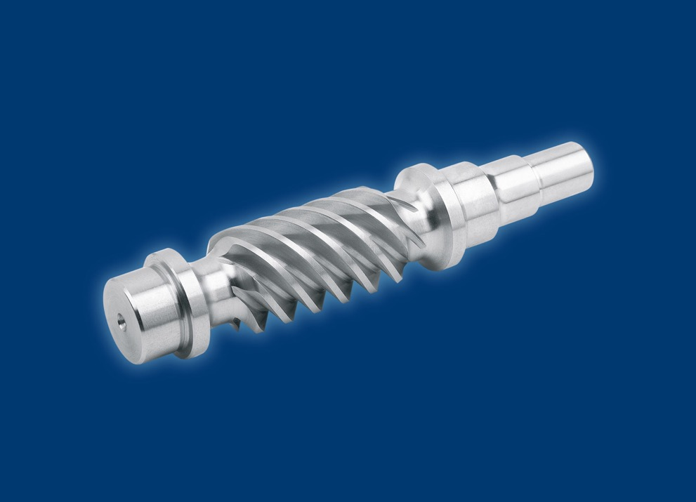
02_Blohm_Sonderfertigung.jpg
One example of a particularly demanding customer solution is the production of high-precision worm shafts. For this purpose a blank is hardened and cylindrically ground before being shaped into its rotor profile using a special grinder.
Image: NORMTEILWERK ROBERT BLOHM GmbH

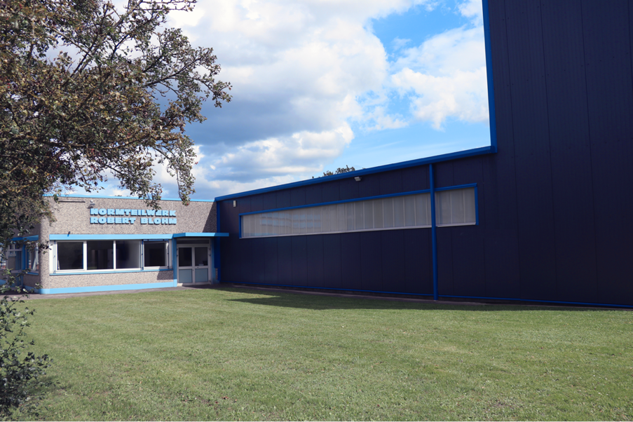
03_Blohm_Sonderfertigung.jpg
Located in Büchen, North Germany: One of BLOHM's strengths is its customer proximity and close co-operation in all phases of a project.
Image: NORMTEILWERK ROBERT BLOHM GmbH

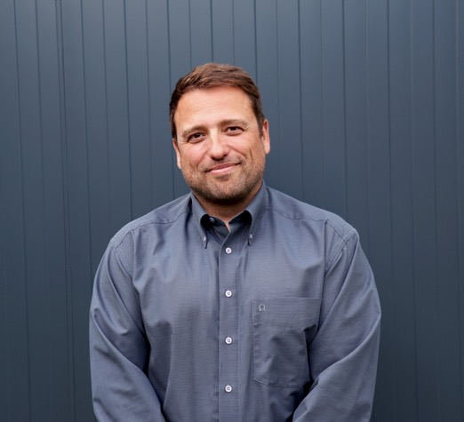
04_Blohm_Sonderfertigung.jpg
Mathias Marbs, sales representative at BLOHM: "Our strength is found in the full production chain that we can map in-house - from turning and hardening to precision grinding and final measurement," explains Mathias Marbs, sales representative at BLOHM.
Image: NORMTEILWERK ROBERT BLOHM GmbH

Meta title: Customised production at NORMTEILWERK ROBERT BLOHM

Meta description: BLOHM stands for high-level expertise in precision production of complex customised special solutions in compliance with the highest quality standards.

Keywords: NORMTEILWERK ROBERT BLOHM, BLOHM, standard parts, special parts, special production, precision grinding, rotor shafts, worm shafts, running spindles, drive spindles, polygonal shafts, turning, hardening, quality, vertical integration

Deeplinks:
https://www.blohm-gmbh.de/de/de/Home.html
https://www.blohm-gmbh.de/de/de/Produkte/Sonderlösungen.html

Download area:
https://www.blohm-gmbh.de/de/de/Download/Pressebereich.html

NORMTEILWERK ROBERT BLOHM GmbH
Adriana Klink
Bahnhofstraße 20
21514 Büchen, Germany
Phone: +49 7454 793-7648
Fax: +49 7454 793-133
Email: adriana.klink@blohm-gmbh.de

Press office:
Köhler + Partner GmbH
Brauerstrasse 42 • 21244 Buchholz i.d.N.
Telephone +49 4181 92892-0 • Fax +49 4181 92892-55
info@koehler-partner.de • www.koehler-partner.de

