Büchen, October 2024

BLOHM at the FMB 2024 between 5th and 7th of November

**Customised Solutions at the Highest Level**

**At this year’s FBM supplier fair in Bad Salzuflen, NORMTEILWERK ROBERT BLOHM, Büchen, will be focussing on its** [**customer-specific special solutions**](https://www.blohm-gmbh.de/de/de/Produkte/Sonderlösungen.html)**. The Büchen-based specialist in the manufacture and sale of standard and precision parts has established itself as a trustworthy partner for customised solutions in this field. Customers benefit from high-performance machining technology and a highly qualified team of experts.**

Customer-specific solutions by BLOHM are used, among others, in machine construction, the automotive industry and aerospace industries. Examples from the Büchen portfolio include rotor and worm shafts, running and drive spindles and polygonal shafts. All of these high-precision special parts are made of durable quality or stainless steel at the production site in the north of Germany.

BLOHM produces its customer-specific rotor shafts for manufacturers of compressors, screw spindles and high-pressure pumps, for example. Worm shafts are specifically manufactured for gearbox construction and are used in worm gearboxes. At BLOHM both types of shaft undergo a precise manufacturing process. "During the three production steps of turning, hardening and cylindrical grinding, we first produce a blank," explains Mathias Marbs, sales representative at BLOHM. "This is then precision-ground – and our expertise here extends right down to the last µm."

**Broad Range of Locating Pins and Rest Pads**

For the exhibition BLOHM brought its broad range of standardise [Rest pads and locating pins](https://www.blohm-gmbh.de/de/de/Produkte/Produktübersicht/Positionierelemente-Anschlagelemente-Auflageelemente/Aufnahmebolzen-Auflagebolzen.html) along. These meet the highest quality and precision requirements when fastening machine elements, stabilising motors or securely mounting electronic components to name but a few. This is primarily due to the fact that all manufacturing processes in this area are also available at the production site in Büchen with particular focus on the use of high-quality materials. This means that locating pins and rest pads are able to be very convincing with their functionality and durability in a wide range of applications.

An example of the locating pin range by BLOHM is the [ball-end locating pin](https://www.blohm-gmbh.de/de/de/Produkte/Produktübersicht/Positionierelemente-Anschlagelemente-Auflageelemente/Aufnahmebolzen-Auflagebolzen/Aufnahmebolzen-mit-Kugelansatz-Form-B.html) – a design that significantly simplifies the assembly process. Because the ball-end minimises the jamming effect – as often experienced with drawers – if a part to be mounted is at an angle or the forces acting on it are not along the axis of the pin. " BLOHM offers different models with different forms of this type, to suit various requirements and fits."

**Visit us at the FMB 2024 in Bad Salzuflen between 5th and 7th of November in Hall 20, Booth H40.**

*(Characters including spaces: 2,734)*

**Short profile of NORMTEILWERK ROBERT BLOHM**

NORMTEILWERK ROBERT BLOHM, founded in Schleswig-Holstein in 1934, is a renowned manufacturer of drill bushes and sophisticated customised solutions. The company also offers its customers a comprehensive range of standard and operating parts. For 90 years, BLOHM has been an internationally renowned specialist for the production of rotationally symmetrical parts and has always stood for the highest precision and quality.   
Our portfolio includes around 38,000 high-quality products that, due to their stability, can withstand high loads and also meet special requirements. We are therefore primarily targeting partners from trade and industry who rely on durable, high-quality parts. We have high-performance, state-of-the-art machinery for the production of precision parts at our disposal. Possible areas of application for the various bushes and standard parts are machine, special machine and plant construction as well as mould and tool making. We value long-term partnerships with our customers, highest quality and timely delivery. With foresight, we have also been training the next generation of skilled workers for decades.

**Image overview:**

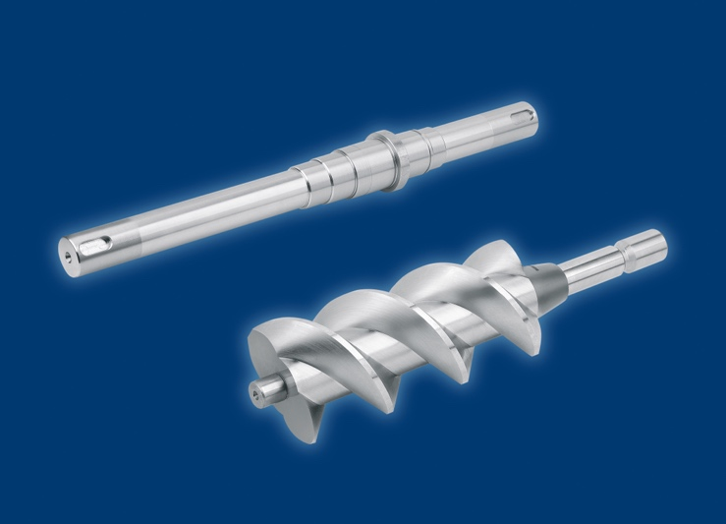

Customer-specific solutions by BLOHM are used, among others, in machine construction, the automotive industry and aerospace industries

*Image: NORMTEILWERK ROBERT**BLOHM GmbH*

**Ein Bild, das Im Haus, Kleidung, Ausstellung, Firma enthält.
**

Between the 5th and 7th of November, NORMTEILWERK ROBERT BLOHM will be showcasing its customer-specific special solutions at FMB 2024 in Bad Salzuflen.

*Image: NORMTEILWERK ROBERT**BLOHM GmbH*

**Meta title:** BLOHM at the FMB 2024 between the 5th and 7th of November

**Meta description:** At this year's FBM supplier fair in Bad Salzuflen, NORMTEILWERK ROBERT BLOHM, Büchen, will be focussing on its customer-specific special solutions.

**Keywords:** NORMTEILWERK ROBERTBLOHM, BLOHM, special production,, rotor shafts, worm shafts, running spindles, drive spindles, polygonal shafts, locating pin, rest pads, standard parts, operating parts, drill bushes

**Deeplinks:**

<https://www.blohm-gmbh.de/de/de/Messen.html>

<https://www.blohm-gmbh.de/de/de/Home.html>

<https://www.blohm-gmbh.de/de/de/Produkte/Sonderlösungen.html>

<https://www.blohm-gmbh.de/de/de/Produkte/Produktübersicht/Bohrbuchsen.html>

<https://www.blohm-gmbh.de/de/de/Produkte/Produktübersicht.html>

**Download-Area:** <https://www.blohm-gmbh.de/de/de/Download/Pressebereich.html>

**NORMTEILWERK ROBERT BLOHM GmbH**

Adriana Klink  
Bahnhofstraße 20  
21514 Büchen  
Telefon: +49 7454 793-7648  
Telefax: +49 7454 793-133  
E-Mail: [adriana.klink@blohm-gmbh.de](mailto:adriana.klink@blohm-gmbh.de)

**Press office:**

Köhler + Partner GmbH

Brauerstrasse 42 · 21244 Buchholz i.d.N.

Telephone +49 4181 92892-0 · Fax +49 4181 92892-55

info@koehler-partner.de · [www.koehler-partner.de](http://www.koehler-partner.de)