NORMTEILWERK ROBERT BLOHM supports Veigel, the mobility specialists

**Becoming mobile, staying mobile -**

**or how a tree frog inspired an invention 100 years ago**

**Mobility means freedom. The technology from Veigel provides the gateway to this privilege and at the same time guarantees that no one is excluded from it. The dual controls for driving school cars and the vehicle accessories for people with disabilities are universally applicable and offer the user not only a lot of driving pleasure, but also the highest level of safety and quality. Veigel also demands the latter from its suppliers and has found a perfect partner in NORMTEILWERK ROBERT BLOHM, and not only in this respect.**

Have you obtained a driving licence in the last few decades? Or are you in the process of doing so? Then you have most likely already come into contact with the technology of Veigel GmbH + Co KG. The long-established company from Öhringen in Baden-Württemberg, Germany has been in the forefront of mobility for more than 100 years and is today not only Europe's leading supplier of dual controls for driving school vehicles, but also, with its rehamotive division, an important initiator in the field of accessibility and inclusion.

In both sectors, the reliability of the technology used is an absolute must. And this does not only apply to the production at Veigel itself, which is certified according to ISO 9001/14001 and IATF 16949, but also to the products and components of all suppliers that are installed in the systems. So it can be helpful if you know your partners well and follow the same philosophy in terms of quality and communication. "Due to my many years of working for a sister company of BLOHM, I was already very familiar with the expertise in the fields of hardening, grinding and milling there, as well as for special solutions," says Markus Koffler, now Purchasing Manager at Veigel, citing the impetus for the cooperation. "I knew the manufacturing capabilities and quality standards of BLOHM and wanted to use them for us as well. The fact that BLOHM manufactures its products in Büchen in northern Germany also fits in with our strategy of buying locally instead of globally."

Together with Mathias Marbs, sales representative at BLOHM, standard parts and special solutions were discussed, which Veigel has since been purchasing from BLOHM. "Our goal was to find out which parts Veigel requires that we either already have in our standard range or can manufacture and supply through our special solutions range," Mr Marbs explains. "This was followed by the preparation of quotations, the provision of samples, the auditing of the desired components and finally the first framework agreement. Since then, we manufacture and store the annual requirements of various components and Veigel then calls them up from us just in time."

**Dual controls with rollers from BLOHM**

The start was made in 2012 with rollers in two sizes, which BLOHM manufactures as a customised special solution, and with which the Büchen-based company secured a permanent place in Veigel's **dual control sector**. These so-called driving school pedals go back to an invention of the company founder Wilhelm Veigel, which was born out of necessity in the 1920s. Due to a lack of driving schools Veigel, at that time one of the first Opel dealerships in the region, had to act not only as a sales consultant but also as a driving instructor for the **4-hp Opel Laubfrosch** (tree frog), which was the modern automobile of the time. "That didn't always go smoothly but, depending on the talent of the learner, sometimes ended up in a ditch or on the side of a house," Mr Koffler recounts. "In a pub, together with a local plastic moulder, Wilhelm Veigel developed a solution - the prototype of today's dual controls." With the introduction of compulsory driving lessons at the beginning of the 1950s, demand for the invention, which had long since been patented, rose sharply. Today, Veigel's market share in this business segment is around 80 per cent.

Veigel's dual controls are manufactured to the highest standards and meet the stringent requirements of the automotive industry. Thanks to the perfect adaptation possibilities, simple installation, trouble-free operation and easy dismantling, Veigel products can be found in almost all vehicle manufacturers' factory programmes - in cars as well as in trucks or buses. "There is actually no vehicle that we cannot equip," Markus Koffler emphasises. "We now have **975 different variants** in our range, with which we cover the complete span from Ferrari to motorhome - and the rollers from BLOHM are present in them all."

The rollers in the dual controls ensure the easy operation of the brake pedal and clutch by the instructor. Both pedals are each connected to a slotted lever via a carrier pin, which in turn activates the brake or clutch. If they are not operated, the driving instructor pedals are in neutral mode. Only when the driving instructor presses a pedal does he take over the braking and clutch function. The rollers are located between the carrier pin and the slotted lever and - similar to a plain bearing - ensure the lowest possible friction between the two components.

**Hand controls ensure mobility and participation**

The rehamotive division has complemented the Öhringen-based company's portfolio since 2000 and has grown to around 350 different products to date. The most important segment here is the diversely equipped hand controls, in which BLOHM has participated since 2019 with a specially manufactured accelerator shaft. In addition, Veigel develops, among other things, slide boards, swivel and transfer seats as well as wheelchair loading systems. "For a physically disabled person, we can transfer all the functions normally performed by the legs to the hands," Markus Koffler explains. "On one side, usually to the right of the driver next to the centre console, is the hand control for accelerator and brake. A multifunction knob on the steering wheel controls the indicators, headlight flasher, windscreen wipers and all secondary functions that are otherwise operated via buttons and rocker switches." Since one of the driver's hands always remains on the steering wheel, Veigel ensures the prescribed road safety for these fixtures. Alternatively, all functions can be integrated directly into the hand control.

The employees at Veigel are proud that people with disabilities are regaining freedom and mobility through these developments. "We are shaping a world in which mobility knows no boundaries - that is our guiding principle and also our contribution to inclusion and participation," explains Luigi Savignano, Head of Marketing at Veigel. "In addition, we attach great importance to appealing, ergonomic design and the high intrinsic value of our rehab products. These are so designed that they integrate perfectly into the vehicle and, in the best cases, are not even perceived as optional equipment."

The success of this is demonstrated by a whole series of design awards with which the rehamotive portfolio has already been honoured. But the high design demands, in combination with the usually tight installation spaces are also a challenge for construction and production. "Hand controls are becoming increasingly slimmer and more ergonomic, yet they still have to be stable and functional," says Markus Koffler, describing the development. "To live up to that, I need quality products. With the accelerator shafts that we install in the hand controls, BLOHM has implemented our requirements so effectively that we have been sourcing these special parts from them since 2019." The ca. 10 x 150 mm accelerator shafts are installed in the top of the hand control. They transmit the driver's impulse on the accelerator grip to the vehicle's electronics and thus regulate the speed.

**Respectful cooperation on an equal footing**

Over the course of time, the good cooperation between Veigel and BLOHM has repeatedly resulted in new projects. Both partners praise the high quality standards of the other and the good and close cooperation. "The products from BLOHM have high technical standards, the workmanship is of very good quality and the employees are competent", praises Markus Koffler. "But what is almost more important to me is good partnership-based communication, and that works excellently with BLOHM - as equals and with respect".

*(Characters including spaces: 8,353)*

**A short profile of Veigel GmbH + Co. KG**

Founded in 1920 by Wilhelm Veigel as a car workshop in Künzelsau, Veigel GmbH + Co. KG is today Europe's leading manufacturer of dual controls for driving school vehicles and, with around 350 products, an important driving force in the field of car equipment for the disabled. Since 1995, this entrepreneurially managed mid-sized company has been owned by the Swyter family. Wilhelm Veigel is regarded as the inventor of the dual pedal set, and accordingly the manufacturer holds numerous patents in this segment. The company entered the rehamotive sector in 2000 with the acquisition of the Bruhn company. Today, around 80 employees work at the company's new headquarters in Öhringen, Baden-Württemberg. Furthermore, Veigel is represented worldwide by subsidiaries and agencies - always with the aim of making mobility accessible to all.

**Short profile about NORMTEILWERK ROBERT BLOHM**

NORMTEILWERK ROBERT BLOHM was founded in 1934 and is a renowned manufacturer of drill bushes, standard and operating parts as well as sophisticated special solutions according to customer drawings. For more than 80 years, BLOHM has been an internationally renowned specialist for the production of rotationally symmetrical parts and has always stood for the highest precision and quality.   
Our portfolio includes around 28,000 high-quality products that, due to their stability can withstand high loads and also meet special requirements. This means that we can primarily target partners from trade and industry who rely on durable and high-quality parts. We have our own high-performance and modern machine park at our disposal for the production of precision parts. Possible areas of application for the various bushes and standard parts are machine, special machine and plant construction and mould and tool making. We value long-term partner relationships with our customers, highest quality and on-time delivery. With an eye on the future, we have also been providing training for the next generation of skilled workers for decades.

**Image overview:**

**Veigel_Firmensitz.jpg**

Ein Bild, das Himmel, draußen, Gebäude, Architektur enthält.

Company headquarters of Veigel GmbH + Co. KG in Öhringen. In 2016, the specialist for dual controls and disability-friendly vehicle equipment moved into its new customer, development and production centre. Image: Veigel GmbH + Co. KG

**Veigel_Markus_Koffler.jpg**

Ein Bild, das Menschliches Gesicht, Kleidung, Person, Lächeln enthält.

Markus Koffler, Purchasing Manager at Veigel GmbH + Co KG: "The products from BLOHM have high technical standards, the workmanship is of very good quality and the employees are competent. We also maintain good and partnership-based communications - as equals and with respect." Image: Veigel GmbH + Co. KG

**Veigel_Luigi_Savignano.jpg**

Ein Bild, das Menschliches Gesicht, Kleidung, Bart, Person enthält.

Luigi Savignano, Marketing Manager at Veigel GmbH + Co KG: "We are shaping a world in which mobility knows no boundaries - that is our guiding principle and also our contribution to inclusion and participation." Image: Veigel GmbH + Co. KG

**Veigel_Doppelbedienung_1.jpg**

Ein Bild, das Waffe, Farm, Maschine enthält.

The dual controls go back to an invention of the company founder Wilhelm Veigel. Today, with 975 product variants, Veigel holds a market share of 80 percent in this segment. Image: Veigel GmbH + Co. KG

**Veigel_Doppelbedienung_2.jpg**

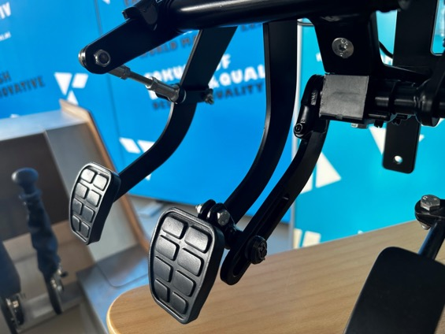

Veigel's dual controls are manufactured to the highest standards and meet the stringent requirements of the automotive industry. Thanks to the perfect adaptation possibilities, simple installation, trouble-free operation and easy dismantling, Veigel products can be found in almost all vehicle manufacturers' factory programmes - in cars as well as in trucks or buses. Image: Veigel GmbH + Co. KG

**Veigel_Doppelbedienung_Laufrolle.jpg**

Ein Bild, das Im Haus, Gelände enthält.

Since 2012, BLOHM has been supplying specially manufactured rollers for Veigel's dual controls. These ensure easy and smooth operation of the brake pedal and clutch by the driving instructor. *Image: Veigel GmbH + Co. KG*

**Blohm_Laufrollen.png**

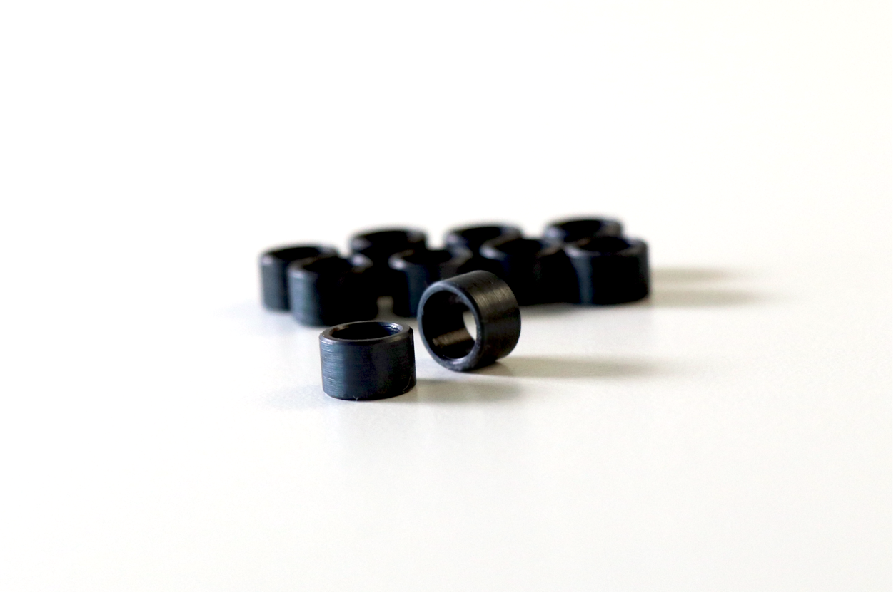

These BLOHM rollers are now firmly established in Veigel's dual controls. *Image: NORMTEILWERK ROBERT**BLOHM GmbH*

**Veigel_Handbedienung_eClassic.jpg**

Ein Bild, das Mittelkonsole, Fahrzeug, Lenkrad, Auto enthält.

The hand controls from Veigel GmbH + Co. KG, here the model eClassic, are so designed that they integrate perfectly into the vehicle and, in the best cases, are not even perceived as optional equipment. Image: Veigel GmbH + Co. KG

**Blohm_Gaswellen.png**

Ein Bild, das Büroausstattung, Stift, Bürobedarf, Kugelschreiber enthält.

The specially manufactured accelerator shafts from BLOHM are used in Veigel's hand controls. *Image: NORMTEILWERK ROBERT**BLOHM GmbH*

**Veigel_Zeichnung_Gaswelle.jpg**



The ca. 10 x 150 mm accelerator shafts from BLOHM are installed in the top of the hand control (2). They transmit the driver's impulse on the accelerator grip (1) to the vehicle's electronics and thus regulate the speed. Image: Veigel GmbH + Co. KG

**Blohm_Mathias_Marbs.jpg**

Ein Bild, das Kleidung, Menschliches Gesicht, Person, Hemd enthält.

Mathias Marbs, Sales Representative at BLOHM: "At the beginning of our cooperation, it was a matter of finding out which parts Veigel requires that we either already have in our standard range or can manufacture and supply through our special solutions range. Today we manufacture and store the annual requirements of various components and Veigel then calls them up from us just in time." *Image: NORMTEILWERK ROBERT**BLOHM GmbH*

**Meta title:** Partnership in the service of mobility

**Meta description:** Veigel GmbH + Co. KG cooperates with NORMTEILWERK ROBERT BLOHM on dual controls and rehamotive products.

**Keywords:** NORMTEILWERK ROBERTBLOHM, BLOHM, Veigel GmbH + Co. KG, dual controls, driving school pedal sets, driving school, hand controls, rehamotive, swivel seat, transfer seat, wheelchair loading systems, roller, accelerator shafts, standard parts, special parts, custom made,

**Deeplinks:**

<https://www.blohm-gmbh.de/de/de/Home.html>

<https://www.veigel-automotive.de/>

**NORMTEILWERK ROBERT BLOHM GmbH**

Adriana Klink  
Bahnhofstraße 20  
21514 Büchen, Germany

Telephone: +49 7454 793-7648  
Fax: +49 7454 793-133  
Email: [adriana.klink@blohm-gmbh.de](mailto:adriana.klink@blohm-gmbh.de)

**Press office:**

Köhler + Partner GmbH

Brauerstrasse 42 · 21244 Buchholz i.d.N.

Telephone +49 4181 92892-0 · Fax +49 4181 92892-55

info@koehler-partner.de · www.koehler-partner.de